[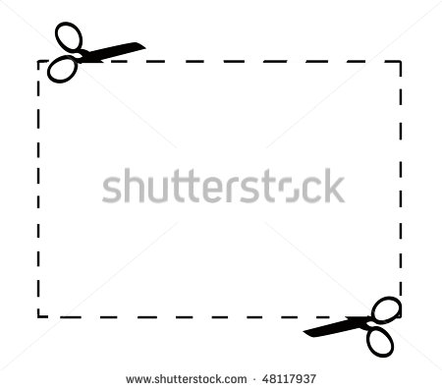](http://www.google.com/url?sa=i&rct=j&q=&esrc=s&source=images&cd=&cad=rja&uact=8&ved=0ahUKEwi9nZXlge7LAhXIox4KHYjcBycQjRwIBw&url=http://all-free-download.com/free-vector/dotted-line-clip-art.html&psig=AFQjCNF832FF3qO7CEng9i3SzOX16j7tnw&ust=1459619809888429)

**4th Grade Supply List**

**Bridge Valley Elementary School**

**2022-2023**

* Expo Marker
* Whiteboard Eraser or Sock
* Colored pencils
* 8 count thin markers
* 7 pocket folders **with prongs** in the following colors:
  + red, orange, yellow, green, blue, purple, black
* 1 **red** spiral notebook
* 2 black and white marble composition books
* 1 plastic/ fabric zippered pencil case
* 1 pair of headphones

**Optional Supply Items:**

* 1 box of tissues
* 1 container of Clorox wipes